**Regular Complexities:**

**Lebanese Water Issues**

Travis Yates

For: Water Diplomacy I

CEE 194-A

CONTENTS

1 Abstract 4

2 Natural, Historic, Economic, Regional and Political Framework 5

2.1 Geography, Hydrology & Water Details 5

2.2 Political Background 8

2.3 Water Governance 9

2.4 Water Governance Challenges 12

2.5 Refugees in Lebanon 12

3 Stakeholders 15

4 Uncertainty 16

4.1 Uncertainty: Brugnach et al. 16

4.2 Uncertainty: Susskind & Islam 17

5 Analysis, Syntheses, and Insight 18

5.1 Addressing Uncertainty 18

5.2 Opportunity for Water Diplomacy 19

6 Key Questions 21

6.1 How can government be dis/incentivized to offer an inclusive planning process? 21

6.2 How do national policies influence water use at the local level? 21

6.3 How can consultation and cooperation among stakeholders and development partners be better facilitated/managed/fostered? 22

7 Other Considerations 22

8 References 24

List of Figures

Figure 1: Lebanon geographical & topography map 6

Figure 2: Annual Precipitation Lebanon (mm) Shaaban 2009 7

Figure 3: Historical precipitation Data (World Bank Group) 8

Figure 4: Lebanon Timeline (BBC) 9

Figure 5: Data Exchange between government water stakeholders (UNESCWA) 12

Figure 7: Syrian Refugee Population in Lebanon (UNHCR) 14

List of Tables

Table 1: Technical Water Constraints (El-Fadel et. al.) 8

Table 2: Lebanese Water Law (ARD) 10

Table 3: Department and role of water actors (ARD) 11

Table 4: Water Challenges 13

Table 5: National Stakeholders 16

Table 6: International Stakeholders 16

Table 7: Uncertainty of Lebanese Water 17

# Abstract

Lebanon has witnessed decades of war and civil unrest, leaving the effective management of the country’s water resources in a vulnerable state. Lebanon is in a water stressed region with increasing water demand (Q, P) and a diminishing water supply due to climate change. The government authority (G) is weak and unable to sufficiently manage municipal water networks or environmental concerns (E). Further complicating the water demands is a refugee influx of nearly one million Syrians with unique humanitarian water and sanitation needs (Q, P, V). Here we find that the water resource management situation within Lebanon falls into a complex realm with significant uncertainties. Addressing the uncertainties through a water diplomacy framework could prove highly beneficial. Several concepts such as mutual gains, joint fact finding, and collaborative adaptive management would bring in multiple stakeholders, address underlying values among varying parties, and provide an opportunity to enable progress for positive change.

*Questions Addressed and Wisdom Gained*

The key question raised from this case is, ‘how can Lebanon’s water resource management improve given the political discourse, current and future water strain, and increased burden from a refugee influx?’ Here we find that a lack of accountability within the government has left a disappointed population that self-adapted to meet individual rather than national water concerns. Thus, stakeholder involvement with appropriate and actionable follow-up by government policies will provide credibly for improving water policies. Given Lebanon’s situation, change in the policy and operation of the water resources is inevitable and stakeholder involvement coupled with accountability would set a foundation for water sustainability for future generations. Water Diplomacy principles have been shown to provide improved satisfaction among stakeholders in both the process and output of water negotiations. These principles should be continually applied to other complex situations around the globe.

# Natural, Historic, Economic, Regional and Political Framework

## Geography, Hydrology & Water Details

*Hydrology, Quantity, and Quality:*

Lebanon is a rather small country of about 10,500 km2 (UN Data) but has a very diverse topography. Bordering only Syria and Israel, the topography of Lebanon is striking as there are enormous differences between the Mediterranean coastline and 3,000 meter (~10,000 feet) mountains. Lebanon has more water than other Middle Eastern countries receiving about 8.6 to 10 BCM (billion cubic meters) per year which translates to about 1,700 m3 per person (Haddadin). Comparatively, Israel and several countries on the Arabian Peninsula operate on about 650 m3 and the world average of water resources per capita is about 4,800 m3 per person (Berkoff 1994). Thus Lebanon is relatively water strong for the region, yet remains water strained.

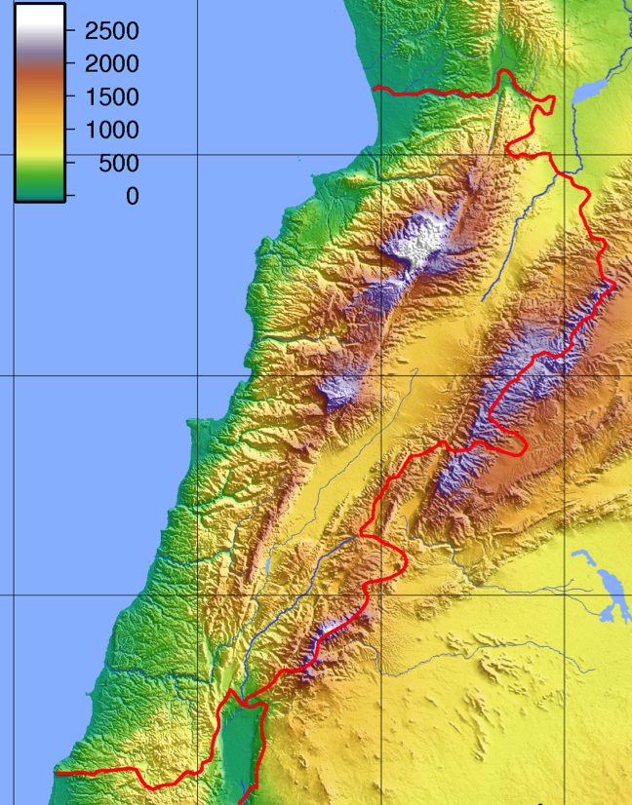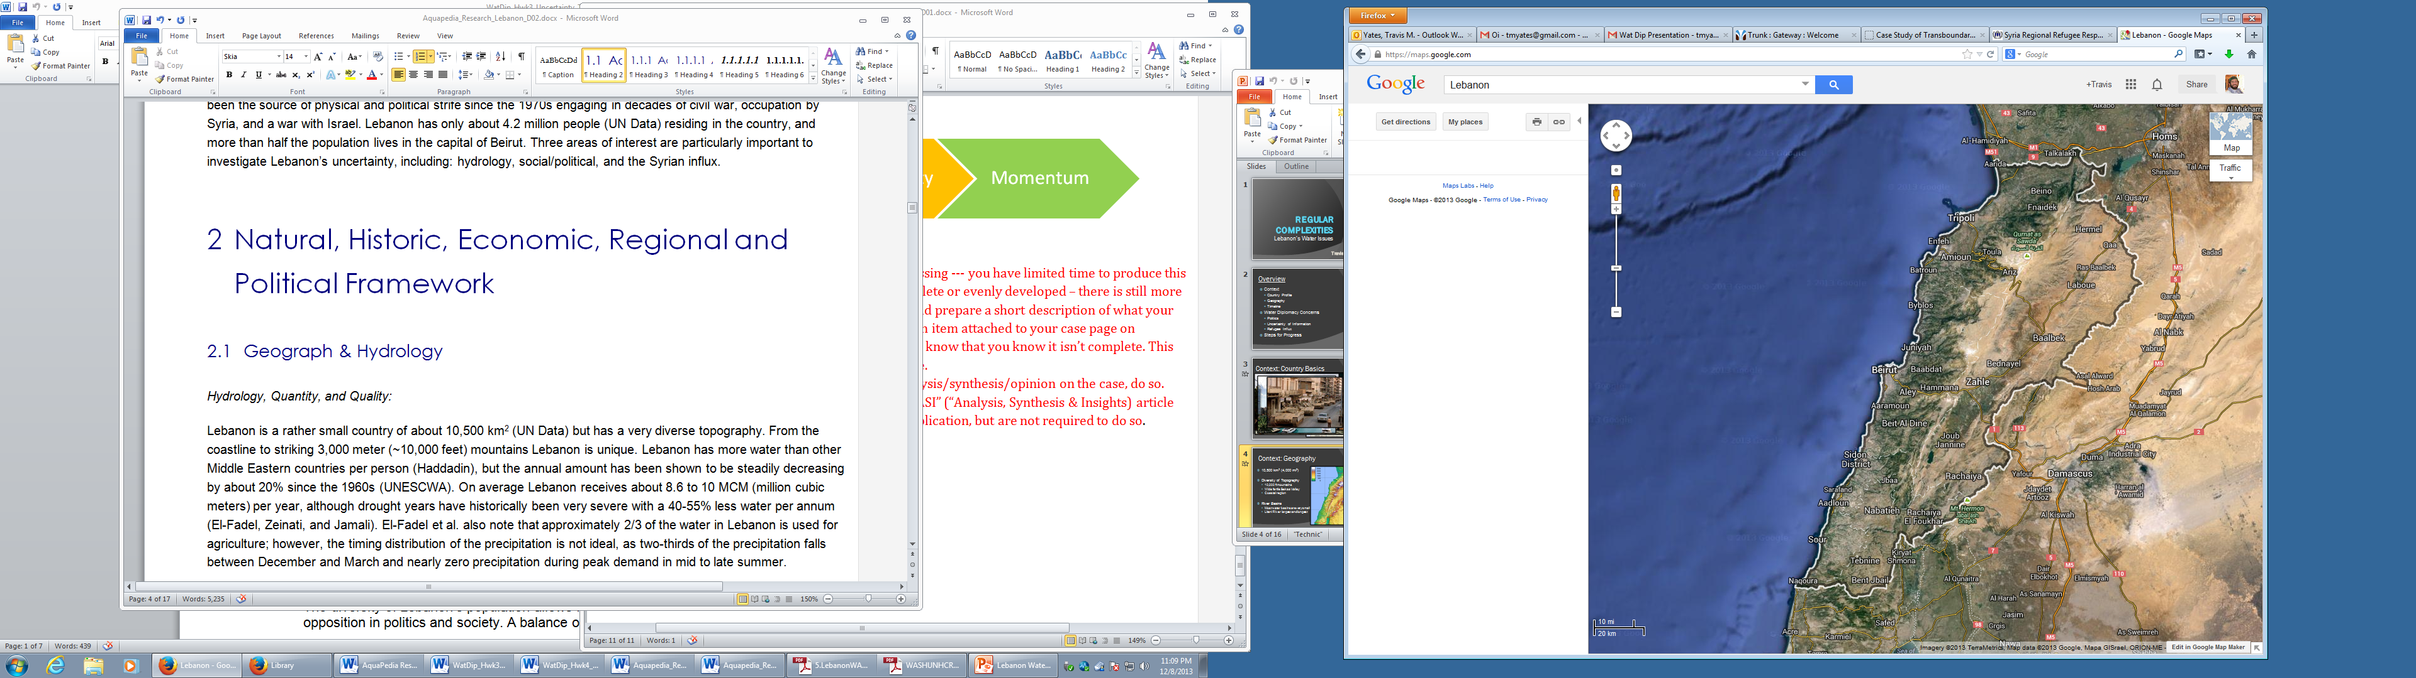

Figure 1: Lebanon geographical & topography map

The water strain in Lebanon is noted by El-Fadel, Zeinati, and Jamali who state that current water resources often fall short of meeting demand, leaving the general population and industry without water. They also reference an ESCWA report stating, “Rapid growth and development in the region have led to mounting pressures on scarce surface and groundwater resources to satisfy water demands (1998).” Moreover, the current level of consumption for domestic, industrial and agriculture use is simply not sustainable for the future. Bou-Zeid and El-Fadel also support this notion, and comment that available water resources across the Middle East will fall to 667 m3 per person by 2025 due to population growth alone. El-Fadel et al. commented on water balance held a range from 400-1000 BCM/yr, while also noting a lack of knowledge in many hydrologic measures. Domestic user rates also vary greatly depending on the source and industrial demands are similarly unknown (El-Fadel, Zeinati, and Jamali).

While acknowledging that future demand will put strain on the water resources of Lebanon, a potentially more pressing threat is the water availability itself. As shown in Table 2 the annual precipitation has been steadily decreasing since the 1960s. This decline averages to approximately a 20% decrease in precipitation over the last 50 years. Similarly, monthly precipitation data as shown in Figure 3 also shows a decline in availability by about 8%; however several months display a decline by 12-13% and no months increase precipitation. In many regions of the world, climate change models often show a shift in frequency and schedule of precipitation, although it appears that Lebanon has little variation in timing but a fairly consistent decline in precipitation across the year.

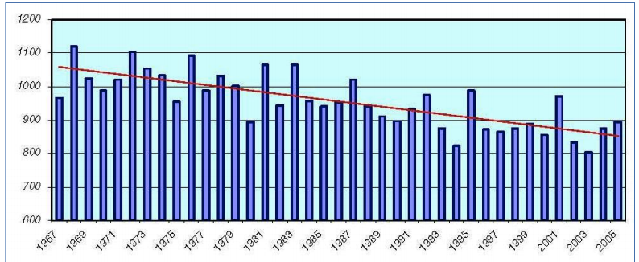

Figure 2: Annual Precipitation Lebanon (mm) Shaaban 2009

A possible impact of climate change is also the impact of droughts in Lebanon. Historically, droughts have been very severe with a 40-55% less water per annum (El-Fadel, Zeinati, and Jamali). These droughts have a particular impact on the agriculture sector as El-Fadel et al. also note that approximately two-thirds of the water in Lebanon is used for agriculture. As noted above, the timing distribution of the precipitation is not ideal, as two-thirds of the precipitation falls between December and March and nearly zero precipitation during peak demand in mid to late summer, see Figure 3. The construction of the Qaraoun Dam on the Litani River in the Bekaa Valley is the country’s largest and was constructed in 1959 to generate power but also stabilize drinking and irrigation water supply.

Figure 3: Historical precipitation Data (World Bank Group)

The water quality in Lebanon contrasts widely, but is regularly very poor. There is often raw sewage and industrial waste that is openly dumped into streams and rivers. (El-Fadel, Zeinati, and Jamali; Assaf and Saadeh) Technical constraints in Lebanon are described in Table 1 below that further complicate the operation and management potential for the country.

Table 1: Technical Water Constraints (El-Fadel et. al.)

|  |  |
| --- | --- |
| Constraints | Exhibitied |
| Crumbling water distribution networks (municipal and irrigation) | Large losses in excess of 50%, insufficient number of water treatment facilities |
| Groundwater contamination | Biological and chemical pollutants – lack of enforcement |
| Illegal connections (or removal of flow meters) to the municipal water network and irrigation supplies | Lack of capital to invest and maintain with a lack of enforcement |
| Design of current water systems cannot adapt for future demand | Isolated systems not designed for larger populations or development |

There are many hurdles for suitable water management from the natural and technical fields; yet the potential for even greater strain remains a constant threat without deliberate action.

## Political Background

To understand the politics of Lebanon, knowledge on the history of the country is compulsory because so much of society and government structures grew out of the turbulent past. After World War I and the fall of the Ottoman Empire, Lebanon was formed by the League of Nations. A very brief summary of events is outlined below in Figure 4.

|  |  |
| --- | --- |
| 1915 |  |
|  | 1920 |
| 1925 | 1920 – 1943: French Occupation |
|  | 1930 |
| 1935 | 1932: Census |
|  | 1940 |
| 1945 | 1944: Indepenance from France |
|  | 1950 |
| 1955 |  |
|  | 1960 |
| 1965 |  |
|  | 1970 |
| 1975 | 1975-1990: Civil War |
|  | 1980 |
| 1985 | 1982: Israel Invades Lebanon |
|  | 1990 |
| 1995 | 1990 – 2005: Syrian Occupies Lebanon |
|  | 2000  2006: Israel- Lebanon War |
| 2005 |  |
|  | 2010 |
| 2015 | 2011- Present: Syrian Refugees flee to Lebanon |

Figure 4: Lebanon Timeline (BBC)

The last 50 years of Lebanon’s history is marked with war and decades of foreign occupation, both evoke emotions that do that do not quickly fade. The 15 years of civil war segregated much of the country and was based on religious and ethnic tensions. The conflict only ended when Syria stepped in to stop the fighting, but these divisions were present long before the civil war. A balance of power was established under French occupation in the 1920s-30s that divided government positions by religion based on the census in 1932. This disbursement of positions was based on the recognition of 19 religions at the time of the census. The representation of religions was dictated during the French rule and gave the majority of power to the Christians based on census information. In an attempt to gain national unity despite a specific allocation of roles, the government was structured around a sharing of power between the president, prime minister, and the speaker of the house, but also goes on to dictate that the president to be Maronite Christian, the prime minister to be Sunni Muslim, and the speaker of the house to be Shi’a Muslim. As such, any political move also becomes a religious statement that represents various geographic portions of the country. No census has been carried out since 1932 leaving much to be known of the population which vary between 3.6 and 7.1 million people (El-Fadel), although about 4.2-4.5 million is generally accepted. More importantly however, is the shift in religious majority within Lebanon. While exact percentages are not known, it is known that Christians no longer maintain the majority and has been the case for decades. Arguably, the balance of power has made the government highly ineffective as Christian, Sunni, Shia, and 16 other religions are specifically represented in each government office with their own political agendas. A new census would provide political power to change the constitution and upset the current allocation of power, thus a new census is not likely to be had any time soon.

## Water Governance

The government structure to manage water resources is itself, a complicated array of agencies and policies. It has taken nine separate laws or decrees since 1966 to arrive at the current structure that remains a web of uncertainty. Table 2 outlines the legal progression over the last 47 years.

Table 2: Lebanese Water Law (ARD)

|  |  |  |
| --- | --- | --- |
| Legislative Document | Year | Summary |
| Law 20/66 | 1966 | Establishes the Ministry of Hydraulic and Electrical resources |
| Decree 5469 | 1966 | Organizes and defines the role of the Ministry of Hydraulic and Electrical resources |
| Decree 9365 | 1968 | Sets principle for water projects budget preparation and certification |
| Decree 14607 | 1970 | Forms a committee to solve disputes within the ministry |
| Law 221 | 2000 | Amends and modifies the role of the Ministry of Hydraulic and Electrical Resources |
| Law 241 | 2000 | Cancels the Ministry of Hydraulic and resources, merges into Ministry of Energy and Water and amends the organization |
| Law 103 | 2000 | Gives director general authority |
| Law 377 | 2001 | Adds municipal wastewater to the ministry’s authority |

The creation of the Ministry of Energy and Water should have helped to streamline the operation and management of Lebanon’s water resources; yet the governmental structure remains bureaucratic and complex. Table 3 below outlines the general roles of the government departments related to water operations. Several publications after 2001 do not describe the water governance structure in the same way with the Ministry of Public Works and Regional Water & Wastewater authorities seemingly omitted; this could allude to a lack in clarity of roles and responsibilities.

Table 3: Department and role of water actors (ARD)

|  |  |
| --- | --- |
| Department | Role |
| Ministry of Energy & Water (MEW) | Design and implement large water systems (similar to USACE in the United States). Monitors water quantities, qualities, plans for potable water supply, permitting, environmental concerns, enforcing documents |
| Litani River Authority (OLN) | Potable water supply within GoL county wide plan |
| Ministry of Public Health (MPH) | Water quality testing. Maximum loadings – biological & chemical |
| Ministry of the Environment (MoE) | Environmental Concerns (mainly wastewater) |
| Water Establishments | Economic targets for potable and irrigation water. Monitors water quality influent and effluent |
| Local Municipalities | Supervise projects within borders. Permitting. |
| Other stakeholders* | Supervise public work projects, potable water in displaced areas, plan and implement projects |

* Council for Development and Reconstruction (CDR), Min. of Agriculture, Min. of the Displaced, Min. of Defense (MoD), & Min. of Justice among others

The complicated description of roles is further exemplified through the data exchange among different agencies. This convoluted exchange of information is witnessed in Figure 5 below that showcases 14 different agencies included in collecting and/or disseminating water information.

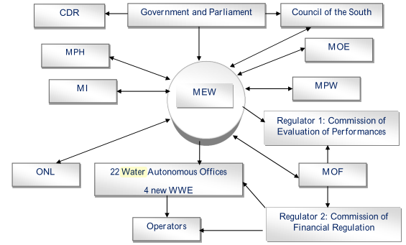

* MEW - M. Energy & Water
* MOE: M. of Environment
* MPW: M. of Public Works
* MOF: M. of Finance
* WWE: Water & Wastewater
* ONL: Latani River Authority
* MI: M. of Interior
* MPH: M. of Public Health
* CDR: Council for Development and Rehabilitation

Figure 5: Data Exchange between government water stakeholders (UNESCWA)

At first glance, Figure 5 appears to positively involve many stakeholders at the national, local and regional levels; however, while nearly every sub-department has direct contact with the Ministry of Energy and Water, there is no clear structure for jurisdiction or authority at lower levels. Not only does this highlight the potential for monopolistic control, it also highlights the potential for inefficiency, as significant amounts of information pass through a single entity, the Ministry of Energy and Water. Government agencies are typically not isolated and need to operate in conjunction with other agencies, yet the data exchange structure seems to rely on fringe stakeholders instead of establishing a hierarchal structure. This could have been established to appease political agenda, thus forcing various involvements and leading to ineffectiveness. The unsuccessful governance has been witnessed by the population and is shown through the lack of enforcement of government policies, including environmental pollution or basic infrastructure. An article from a Lebanese newspaper explains:

“Lebanon has struggled with environmental reform for years. Environment officials and activists say the country’s enforcement of environmental laws has been lax and that the powers of environmental prosecutors are seriously curtailed.” (Daily Star, 9 Nov 2012)

## Water Governance Challenges

The organization of water management is itself a challenge, yet there remains several more aspect that greatly hinders the effective management of Lebanon’s water resources. Some of these are natural constraints but many are a result of years of civil unrest and underdevelopment. El-Fadel summarizes several authors (Nimah & Hajjar, 1995; Ja’afar, 1996; Jaber, 1993, 1996; El-Fadel & Zeinati, 1999) to broadly describe some of the national challenges.

Table 4: Water Challenges

|  |  |
| --- | --- |
| Challenge | Reason or Effect |
| Limited cooperation between water supply and wastewater treatment | Only adopted within Min. of Energy and Water in 2001 |
| Lack of coordination between districts (Cazas) | Irregular water distribution. Local priority rather than regional or national priorities. |
| Disregard of water policies from public | No enforcement of policies |
| Water resource records inconsistent/complete | Records are dispersed among many agencies and not consolidated – minimal sharing of information |
| Overlap in traditional water authorities and new government authorities | Civil war and unrest halted the operation of national entities, a reliance on local providers then prevailed |
| Duplication of authority | Multiple government agencies have authority to carry out water related projects |
| Effective water management | Water authorities defined by political boundaries, not basins. |
| Future water constraints | Policies that reflect practicalities of Lebanese political viabilities  Lack of modern irrigation techniques |

Water governance faces many current and future constraints but also is put under additional stresses such as ‘population growth, industry/agriculture development, ecological needs, climate change, non-sustainable development, and a lack of awareness’ (ARD Report) that further erode the sustainability of Lebanon’s water management in the coming years.

## Refugees in Lebanon

### Palestinian Refugees

About 100,000 Palestinian refugees arrived in Lebanon in 1948 and were never able to return home. In fact, another surge in Palestinian refugees occurred during the Six-Day War in 1967 adding to what is today nearly 450,000 Palestinians living in Lebanon (Amnesty; UNWRA). The Palestinian population currently accounts for approximately 10% of the Lebanese population but often is marginalized without true citizenship anywhere. Many speculate that the influx of Palestinian refugees, whom are primarily Sunni Muslim, helped to ignite the civil war in 1970. There are a dozen Palestinian refugee camps across Lebanon, often in a state of disrepair and severe overcrowding, and remain in a political void with marginalized rights (ANERA). A branch of the United Nations called UNRWA (United Nations Relief and Works Agency) was dedicated to assist in the management and well-being of Palestinian refugees.

### Syrian Refugees

The Arab Spring in 2011 created a great deal of unrest in the Middle East and has continued in Syria for more than two years. To date, more than 2.2 million people have fled Syria for surrounding countries including nearly 900,000 to Lebanon (UNHCR). The Lebanese government disagrees with UNHCRs population estimate as underreporting and has claimed more than one million Syrians have been in Lebanon since December of 2012 (UNHCR). Political and historical pressures did not allow for refugee camps to be established in Lebanon like Jordan and Turkey, because of the (perceived) political and social disruption stemming from the Palestinian influences. This action, or the lack thereof, forced large numbers of families into informal tents across open farmland, unfinished spaces behind shops, and squalid settings throughout Beirut, Tripoli, and other areas all over the country. Approaches to assist this vulnerable population have been stymied by the Lebanese internal political disparity and difficult humanitarian demands from the global community. Without formal refugee management, the Syrian refugee population puts an enormous strain on the local host community, while access to adequate water and sanitation remains dismal (Syrian Needs Assessment Project). Lebanon has failed to adequately address the enormous amount of people that sudden arrived in country, about a 20% increase in population over a two-year period. The infrastructure simply cannot handle the increased and sudden demand.



Figure 7: Syrian Refugee Population in Lebanon (UNHCR)

This enormous influx in refugees would be difficult for any country to address, but further complicating any response is the type of needs for the Syrian refugees. Also, as displayed above, Lebanon cannot adequately meet its own current or future water needs, let alone meet the additional magnitude of the refugee influx – yet immediate needs remain. Further complexities are founded in that the Syrian refugees have inherently different needs than the Lebanese host communities. The refugees find themselves in temporary housing situations that are void of water and sanitation. A large population in rural and peri-urban areas without previous access to municipal supplies differ from the local population needs. The Regional Response Plan (RRP) is a United Nations planning tool to help estimate the current and future needs of the refugees. The water and sanitation needs included in the RRP6 is for 2014 and is summarized in the outputs below:

**RRP6 – Needs and Challenges (UNHCR RRP6)**

**Water**: Sufficient access to safe drinking water is a critical, ongoing need, particularly as the refugee population has put significant pressure on water systems in areas where large numbers of refugees reside.

**Sanitation**: Basic sanitation facilities are a necessity for the health and dignity of refugees. An increasing number of refugees live in informal settlements with limited or no sanitation facilities. This creates increased risk of the spread of preventable diseases. Waste management remains poor in most of places where refugees live, increasing the pressure on host communities.

**Hygiene**: As refugees arrive with few possessions, many lack basic items for personal and household hygiene. Without regular supplies, refugees face deterioration in their wellbeing and dignity. UNHCR provides hygiene kits to newcomers, and refugees continue to receive hygiene items on monthly basis once registered.

**Strained infrastructure in host communities:** The presence of refugees in the local community has put pressure on existing infrastructure and resources including water. Water supply and waste management in areas hosting Syrian refugees have deteriorated. UNHCR is working with local Water Establishments and municipalities to ensure continuous access to safe water at the household level and basic sanitation facilities in all areas under pressure.

There is also the difficult task of prioritizing needs among geographic areas, individual families, and acknowledging the strain on the local host communities. The government of Lebanon has sought assistance from the World Bank to estimate the strain on the country because of the refugee influx in economic indicators. Questions also remain in the timing of available response, potential for contingency measures and scope of potential timeframes. The war in Syria has been on-going since 2011, but no one knows how long it will continue. Due to the time involved in infrastructure projects, the applicability of some projects only become feasible with a two or three year outlook, yet the uncertainly of investment is unclear and quickly becomes a political issue. Ever more strain is experienced when UNHCR estimates that of the 833,000 registered Syrian refugees, more than 725,000 are in need of WASH assistance, but the sector is only 66% funded which leaves enormous unmet voids in humanitarian response. Moreover, contingency measures cannot be conceptualized when current needs remain unaddressed, yet the potential for even more refugees flooding the borders remain a threat as billions of dollars are still needed to respond to the current populations.

# Stakeholders

The interest in water management and water use of Lebanese resources is always a national focus, yet also goes far beyond its own boarders. The utilization of the natural resources could be linked to the stability of the country with regional implications. Several stakeholders are highlighted in the tables below.

Table 5: National Stakeholders

|  |  |
| --- | --- |
| National Stakeholder | Mode of Involvment |
| General Public | Right to water. Access to consistent quantity and appropriate quality. Current and future generation |
| Government (various ministries) | Responsible for provision of water, governance of regulation, and support of economic growth |
| Refugee Populations | Often marginalized with limited rights. Temporary to medium to possibly long term outlook. Unique demands compared to Lebanese host communities |
| Agriculture Sector | Accounts for 65% of water usage and provides large portion of economy and jobs through agriculture products |

Table 6: International Stakeholders

|  |  |
| --- | --- |
| International Stakeholder | Mode of Involvment |
| Syria | Neighboring country. Complicated history with Lebanon. Syrian civil war often spills over into Lebanon with varying effects. Syrian conflict also has potential implications with Iran, China, Russia, the United States and others. |
| Israel | Turbulent history with neighbor including two wars in the past 30 years. |
| United Nations | Responsible to provision of water and sanitation access (and quality) to more than 1.5 Million Palestinian, Syrian, and Iraqi refugees. |
| European Union | Stability in the region |
| United States | Stability in the region |

# Uncertainty

As demonstrated in the context above, Lebanon is a complicated and complex situation. Identifying and qualifying various uncertainties can be used as a tool to then address the issues. The scope of this field is broad, but two methods for quantifying the uncertainties of the Lebanese context were evaluated: Brugnach et al. and Susskind & Islam.

## Uncertainty: Brugnach et al.

Brugnach et al. presents uncertainly through objects of knowledge outlined by van Asselt and Rotmans (2002) compartmentalizing natural, technical, and social systems. They then apply three types of uncertainty: unpredictability, incomplete knowledge, and multiple knowledge frameworks, to describe each of the systems.

Table 7: Uncertainty of Lebanese Water

|  |  |  |  |
| --- | --- | --- | --- |
|  | Unpredictability | Incomplete Knowledge | Multiple Knowledge Frames |
| Natural System | Effects of climate change and the decline of water in the future | How much water is naturally available from precipitation and ground water. Edges of aquifers not fully known. | Wide variety of water balance reports from different studies. Water availability. User rates. Number of users. |
| Technical System | Most studies are projecting short timeframes (10-20 years) as opposed to longer term strategies. Scope of situation and potential technical solutions – very immediate. | Lack of monitoring both water quality and water quantity. Knowledge of water system or hydrologic systems is insufficient. | Appropriate and expectant efficiencies, qualities, quantities vary among stakeholders. |
| Social System | Constantly changing priorities because of national & regional politics, international tensions, and recent influx of refugees. | Understanding the cause and effects of the political and social events. Enormous number of stakeholders complicates processes. | Often disparity by regulators, government agencies, and stakeholders because of ethnic, religious, and political agendas. |

## Uncertainty: Susskind & Islam

The description and qualification of uncertainty by Susskind and Islam provide a tangle breakdown to describe the array of unknowns. They describe uncertainty of information, action, and perception. Using these definitions, the Lebanon context is evaluated.

*Uncertainty of Information*

Across the board, nearly every author or study involving Lebanon mentions something related to uncertainty of information. A lack of information is noted by Doummar et al., UNESCWA, ARD, Jurdi et al., Assef and Saadeh, ANERA, and others that pertain to just about every aspect of a water network, including: aquifers, precipitation, user rates, industry and public demands, but also population statistics, and economic growth. Even when there is information available the variation in quantifiable studies are so wide that uncertainty remains.

*Uncertainty of Action*

The unpredictability of cause-effect relationships permeate throughout Lebanese politics and society. The inefficiency within the government is not unknown or impossible to improve conceptually; it is that the reciprocal effects of policy changes could create highly volatile conflict regionally and/or politically. What is a known is that there is a delicate balance of politics and social norms. At this point, the uncertainty of action actually paralyzes any action at all. From a water management view, changes are necessary in the strategy, infrastructure, and policy but without knowing the current demands and uses, determining the appropriate technologies for expectant outcomes remains aloof.

*Uncertainty of Perception*

This uncertainty weighs very heavily in the Lebanese context. Because of the complicated, turbulent, and even violent past, the stakeholders have come to expect that there will be conflict and political discourse. The public has become very complacent about what to expect from the government noting that as long as there is not war, it is ok, but fail to acknowledge the potential or possibly necessary changes needed for the future. This perception may even hinder projects that would be greatly beneficial for all parties; however, the perception is that politics or something else would likely interfere. Relative to decades of war and strong tensions, the current period of stability is not acknowledged. The population does not talk about ‘*if* there is another war’ but ‘*when* there is another war’ which in turn greatly reduces the outlook on priorities when water projects span decades.

# Analysis, Syntheses, and Insight

## Addressing Uncertainty

Uncertainty will never be eliminated but still must be addressed to be better managed and mitigated. Lebanon is a complex situation that will only continue to have increased uncertainty unless positive steps are taken.

* A better understanding of the countries hydrologic conditions and demands can be carried out through investment in nationwide studies and assessments with additional monitoring equipment. Also, the longevity of the Syrian refugees greatly magnifies nearly all the unknowns’ yet still demands some type of qualification. Adaptive management is becomes more crucial simply to address the dynamics of a constantly changing population.
* The political standoff has crippled much of the effectiveness in the national government; however, not acting is also an action with reciprocal effects. Infrastructure will continue to decline, demands will increase, and climate change may have drastic effects. Some action must be taken and followed up. Establishing conditions that are conducive for government cooperation is imperative for progress to happen.
* A great deal of uncertainty would be eliminated if the social perception were addressed. Keeping the status quo of the social/political balance has kept communities and parties at opposite ends of the social spectrum, afraid of upsetting the perceived balance. Taking on a mutual gains through a water diplomacy approach would reveal underlying issues or values.

## Opportunity for Water Diplomacy

Addressing uncertainty is one aspect of the water diplomacy framework, but pursuing additional water diplomacy frame work criterion such as: Collaborative Adaptive Management, Joint Fact Finding, Stakeholder Involvement, and Mutual Gains could greatly increase the progress toward national progress. These are not new concepts but have only recently been coupled and applied to water issues. Several of these concepts are described below relative to the Lebanese context.

*Joint Fact Finding*

There is a large void of information and general hydrologic data in Lebanon. Even if data exists, the variance among reported numbers creates uncertainty in the process and data itself. Decades of civil war greatly hindered data collection but also augmented distrust on the political and social fronts. To combat these issues, a joint fact finding (JFF) assessment could begin to gain much needed countrywide data, but also provide a starting point for future working relationships. One possible scenario that could prove successful would be to have a non-partisan third party (from outside Lebanon) mandate data collection that utilizes high technology and established global data collection methods. Because the internal politics are so congested at a national and local level, having an outside expert provides a non-partisan authority without political agendas. Hopefully, this would be seen as someone trying to get the best results for Lebanon. This person or agency would also be able to use data collection to gain credibility among the stakeholders. If the data collection were based on what was needed and not set by stakeholders, the internal political debates would be minimized, although the outside party would listen, acknowledge, and adapt strategies if necessary. While acknowledging that data collection can be a source of contention among stakeholders at times, this approach is more of establishing a strong baseline across the country and not debating which data set to use or prioritize. Thus, a non-partisan third party helping to ‘start fresh’ could establish a platform for agreement among the stakeholders.

*Stakeholder Involvement*

Involving as many relevant stakeholders as possible would lend credibility to the process and include local farm coalitions, township and district representatives, tourism sector, hydrologists, climate experts, non-governmental organizations, Palestinian representatives, as well as national government representatives. Involving as many stakeholders as possible will provide much needed momentum and accountability to the process. Previously, there has been a lack of accountability between the national and local governments, which has resulted in a shift of authority from the national government to local and regional areas. Examples include Hezbollah controlled areas of Baalbek in the Bekaa Valley and strong sectarian divisions in Tripoli where national forces have nearly no influence. However, acknowledging the principles for an agreement and moving forward is hopefully important enough to bring all the stakeholders to the table, cultivating opportunities for progress.

*Mutual Gains & Collaborative Adaptive Management*

With respect to mutual gains within a collaborative adaptive management approach, the attitude in Lebanon would likely be considered in contrast to the idea of collaboration. This stems from years of war and civil unrest that dictates inward focused gains. War eliminates long-term social strategies as survival overrules all other priorities. This has precipitated through difficulty in politics because long-term objectives are not prioritized against the immediate needs of security and peace. Mutual gains would be an uphill fight, but the approach could prove most beneficial. This could be seen with an efficient use of strong principles that presents the issues and strategies to overcome them. Also adding credibility from the stakeholders with a sense of ownership would be a welcomed relief from years of conflict. The notion of mutual gains, where there are no ‘winners and losers’ is important concept that is difficult to accept in a war torn country, yet has enormous potential for change. This is especially true when dealing with many minority groups. Establishing both short term and long term goals within a principled strategy would be necessary to show that mutual gains are possible.

Jurdi et al. supports the need for Lebanon to adopt a collaborative adaptive management strategy while also addressing that institutional, legal, and financial constraints hamper Lebanon’s water management. These constraints provide an even stronger call for collaborative adaptive management. Unfortunately, so far, there has been little consensus building among the different ethnic groups and 30 years of civil war have left little ground to start building a foundation of trust. One way to support collective adaptive management would be to start with very small but tangible projects that all parties can get behind. Also, joint fact finding and mutual gains are also elements that support collaborative adaptive management. This acknowledges that agreeing to start a process would be a strong step toward a common long term goal. Adaptive management should address the changing natural and political situations but maintain fairness to all parties. A difficult task in itself, but there remains potential if many stakeholders have identified underlying values and creativity among parties is encouraged.

*Regional Applications*

Haddadin et al. acknowledges many water challenges exist throughout the Middle East that are also exhibited in the Lebanese context. Many of these challenges originate from a general scarcity of water across the region but are augmented by increasing population demand and the strengthening of economies. While water has been a point of contention in the past, it could be used as a springboard for agreement, in Lebanon and also neighboring countries. Aligning of strategies and priorities among the nations could greatly benefit the region and sow some seeds of unity.

# Key Questions

## [How can government be dis/incentivized to offer an inclusive planning process?](http://aquapedia.waterdiplomacy.org/wiki/index.php?title=How_can_government_be_dis/incentivized_to_offer_an_inclusive_planning_process%3F" \o "How can government be dis/incentivized to offer an inclusive planning process?)

The current state of mismanagement and authority should provide a strong basis for an inclusive planning process. Top-down authority is weak already, thus including many local and regional actors should be natural. This also would help to address the regional power structures that have been outside the national government structure. Furthermore, the current challenges are large and require buy-in from the entire population. The government is under-resourced in staff capacity and financially (El-Fadel) so there should be a sizable incentive to bring additional parties into the planning process for ideas but also investment options.

## [How do national policies influence water use at the local level?](http://aquapedia.waterdiplomacy.org/wiki/index.php?title=How_do_national_policies_influence_water_use_at_the_local_level%3F)

National policies have been influential to local users, yet not in a positive way. This can be seen in that only 47% of households were connected to the public water network in 2007 (UNESCWA), illegal connections to the water network (El-Fadel) or that there is a general disregard to the environmental policies by the public (Daily Star). Decades of conflict and unrest eroded the capacity for many federal and local government agencies – water included. Masri (1997) also notes that soil, wildlife, forestry, along with water and other natural resources has a long history of neglect and mismanagement. The lack of capacity has since translated to a crumbling infrastructure (El-Fadel) and a disillusioned population that has little to no expectation from their government. ‘Non-sustainable development and a lack of awareness’ (ARD Report) also highlight a lack of oversight of water resources from the government. This has been exasperated by the structure for water management agencies, but truly is represented in the lack of accountability of those responsible for water governance.

## [How can consultation and cooperation among stakeholders and development partners be better facilitated/managed/fostered?](http://aquapedia.waterdiplomacy.org/wiki/index.php?title=How_can_consultation_and_cooperation_among_stakeholders_and_development_partners_be_better_facilitated/managed/fostered%3F)

Involving all relevant stakeholders would go far beyond government ministries or local water districts to bring in representatives from agriculture, tourism, industry, conservation, and others. This will help with building trust and also transparency to the decisions, while ultimately achieving buy-in among the stakeholders.

*Values*

Many stakeholders only acknowledge actions that have taken place or plan for a terminal output, such as a dam or irrigation diversion. This ‘conclusion thinking’ disregards the values and underlying principles that guide those wants. Ultimately, this limits creativity and drives a ‘winner and loser’ negotiation where one achieves the end goal, or they are unsatisfied with the result. By working to identify underlying values, more creativity can produce deeper and far reaching results for many more parties. This step supports the notion that the resources available could be much larger than, creating a ‘bigger pie.’ In a peri-developed country in the process of rebuilding, acknowledging common goals and understandings can have a far-reaching impact beyond the realm of water.

*Accountability*

Accountability from within and outside the country is important to build trust in the process of any agreement. Being held to agreements and priorities is vital in a country where skepticism between stakeholders is rampant. A non-partisan third party with authority over all stakeholders is necessary to make this achievable. Establishing this outside party would prove difficult, as neutrality is scarce, especially within a single nation, but an outside party that is able to cut through local and national politics would be vital to the process.

# Other Considerations

As naturally demonstrated through this case, there are many factors that were not considered or discussed. This document focused more on the nexus between national politics, data uncertainty, and a sudden refugee influx; focusing on integrated water resource management (IWRM) and Water Diplomacy for individual watersheds would be grounding for many principles discussed above; however, applying these methodologies to the country of Lebanon with its 135 rivers and springs (UNESCWA) as one collective unit would be an interesting consideration of multi-basin management in a relatively small controlled area. Regardless, there remains a great deal to further investigate for a better understanding while acknowledging the dynamic situation of both Lebanon and the region.

# References

Amnesty International. ["Lebanon Exiled and suffering: Palestinian refugees in Lebanon"](http://www.amnesty.org/en/library/info/MDE18/010/2007). 2007. Retrieved 8 November 2013.

ANERA. Palestinian Refugees in Lebanon. Vol. 3. 2012. Print.

Assaf, Hamed, and Mark Saadeh. “Assessing Water Quality Management Options in the Upper Litani Basin, Lebanon, Using an Integrated GIS-Based Decision Support System.” Environmental Modelling & Software 23.10-11 (2008): 1327–1337. Web. 9 Nov. 2013.

Berkoff, J. (1994). “A strategy for managing water in the Middle East and North Africa”. The International Bank for Reconstruction and Development, The World Bank, Washington D.C., USA.

Bou-Zeid, E; M El-Fadel. Climate Change and Water Resources in Lebanon and the Middle East. Journal of Water Resources Planning and Management. 2002.

Brugnach, Marcela et al. “Toward a Relational Concept of Uncertainty : About Knowing Too Little, Knowing Too Differently , and Accepting Not to Know.” 13.2 (2008): n. pag. Print.

Doummar, J. et al. “Optimal Water Resources Management: Case of Lower Litani River, Lebanon.” Water Resources Management 23.11 (2008): 2343–2360. Web. 9 Nov. 2013.

El-Fadel, M., M. Zeinati, and D. Jamali. “Water Resources in Lebanon: Characterization, Water Balance and Constraints.” International Journal of Water Resources Development 16.4 (2000): 615–638. Web. 9 Nov. 2013.

El-fadel, M, M Zeinati, and D Jamali. “Water Resources Management in Lebanon : Institutional Capacity and Policy Options.” 3 (2001): 425–448. Print.

Haddadin, Munther J. “Water in the Middle East Peace Process.” The Geographical Journal 168.4 (2002): 324–340.

Haddadin, Munther J et al. “Water Issues in the Middle East Challenges and Opportunities.” 4.October 2001 (2002): 205–222. Print.

Jurdi, Mey et al. “A Prototype Study for the Management of Surface Water Resources, Lebanon.” Water Policy 3 (2001): 41–46.

Lebanon Map – Figure 1: google maps – 8 December 2013

Masri, R. Environmental challenges in Lebanon. Journal of Developing Societies. 1997.

Precipitation Data- Figure 2: World Bank Group. Climate Change Knowledge Portal. Retrieved Nov. 8, 2013.

Shaaban, Amin. "Indicators and aspects of hydrological drought in Lebanon." Water resources management 23.10 (2009): 1875-1891.

Syria Needs Assessment Project, ACAPS. Lebanon Baseline Information. 2013. Print.

Susskind, L., & Islam, S. (2012). Water Diplomacy: Creating Value and Building Trust in Transboundary Water Negotiations, 1(3).

The Daily Star. Nov. 9, 2012. <http://www.dailystar.com.lb/Article.aspx?id=194414#ixzz2n6K1Gzhz>. Retrieved 9 Nov 2012

Topography Map- Figure 1: Public Domain. Retrieved Nov. 30, 2013. Topography of Lebanon. http://en.wikipedia.org/wiki/Geography_of_Lebanon

UN Data. Lebanon country profile. November 9, 2013.

UNESCWA. WATER IN LEBANON STRATEGIC MANAGEMENT DATA NATIONAL ASSESSMENT MATRIX. 2012. Print.

UNHCR. Lebanon Refugee Map –Figure 7– Syrian Refugees by District in Lebanon. 30 November 2013

UNHCR. RRP6 Planning Doc. WASH Sector Coordination Meeting Presentation. 25 Sept 2013

UNHCR. Syria regional analysis. November 9, 2013. http://data.unhcr.org/syrianrefugees/syria.php

UNHCR. WASH UNHCR Lebanon Monthly Update. October 2013

UNRWA. ["Where We Work"](http://www.unrwa.org/where-we-work). 2013. Retrieved 8 November 2013.